STUDY ABROAD IN SEOUL, KOREA

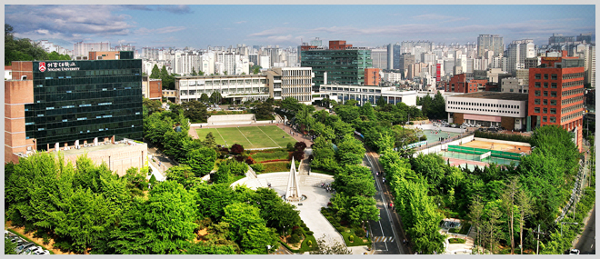 AT SOGANG UNIVERSITY

Sog

Program

Type

Exchange Program

Areas of Study

History, Political Science, Management, International Studies, and Asian American Studies

Courses taught

in English!

Sog

**OVERVIEW**

**PROGRAM DESCRIPTION:** Sogang University, a Jesuit institution in Seoul, South Korea, welcomes undergraduate students from Saint Peter’s University to participate in a student exchange program. Saint Peter’s students participating in the exchange program may register for courses offered in Korean or English. This allows exchange students to experience the unique Korean culture. More info is available here <http://home.sogang.ac.kr/sites/egoabroad/exchange/Pages/Program_Overview.aspx>

**COURSE CREDITS:** Exchange students may take between 12 and 19 credits per semester, which includes Korean language courses.

**TUITION and FINANCIAL AID:** Tuition will be paid directly to Saint Peter’s University based on the regular semester charge. Saint Peter’s institutional aid can be applied to tuition costs, as can government aid. Students pay Sogang directly for student housing in Gonzaga Hall, which includes 2 meals per day.

**FOR MORE INFORMATION**

Please visit the Center for Global Learning in room 524 of the MacMahon Student Center, or contact Scott Keller at (201) 761-6028 or skeller1@saintpeters.edu

Program

Terms/ Deadline

Fall: April 1

Spring: October 1

