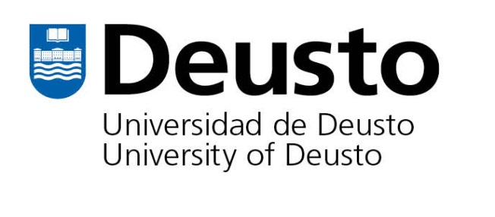

Program Type Program Terms/Deadline Areas of Study Language
Exchange
Courses are taught in English and Spanish
Fall: March 1 Spring: October 1
Business, Psychology, Modern Languages, Law, International Business, Political Science, History

Program Description
Program Type
Exchange Program
The University of Deusto is a private, Jesuit university located in Bilbao, Spain. It is the oldest private institution in Spain. The partnership between Saint Peter’s University and University of Deusto allows you to participate in classes to fully immerse yourself in the vibrant Spanish culture, all at the same cost as attending a semester in Jersey City! All of your scholarships and aid apply.

While in Spain, you can explore Bilbao and countless other cultural heritage sites, including the nearby birthplace of St. Ignatius. More information is available on their website: www.deusto.es/cs/Satellite/estudiantes/en/international-4/incoming-students-0/exchange

Bilbao, Spain
Bilbao is located in the North of Spain, in the heart of the Basque region. Art abounds in this city that is both ancient and modern, at the same time. Deusto is conveniently located across the river from the renowned Guggenheim Museum and five minutes from downtown. Students can visit the Casco Viejo (the old quarter), filled with shops and restaurants, and also explore the newer side of Bilbao, with its modern architecture. It is a very easy city to navigate with easy access to public transportation.
Course Credits
The minimum course load for undergraduate exchange students is 12 credits per semester (4 courses). The maximum course load is 18 credits per semester.

Tuition and Financial Aid
When studying at Deusto, you will pay your tuition and fees directly to Saint Peter’s University based on your regular semester charge. All Saint Peter’s institutional aid can be applied to tuition costs, as can government aid.

Program Fees
*Estimated cost per semester
Airline Ticket (roundtrip) $1,000-$1,500
Insurance $130
Housing (depending on accommodation) $2,000-$5,000
Meals $1000
Transportation $100
Personal Expenses $1,500
Books and Supplies $300

Accommodations
You have an option of living on campus in Colegio Mayor Deusto, a Jesuit-run student residence hall, or the institution will assist you in securing accommodation with a trusted local host family or in a shared flat. Exchange students are encouraged to stay with a host family to fully integrate themselves in the Spanish lifestyle. The deadline for submitting housing application is June 15 (fall semester) and November 30 (spring semester). Check out Deusto University’s accommodations on their website.
Housing is on a first-come first-served basis. Housing rates are between $2,000-$5,000 per semester, depending on the accommodation selected (apartments, rooms, or homestay, with or without meals).

Contact
Please visit the Center for Global Learning in room 524 of the MacMahon Student Center or contact Scott Keller at (201) 761-6028 or skeller1@saintpeters.edu for more information.

