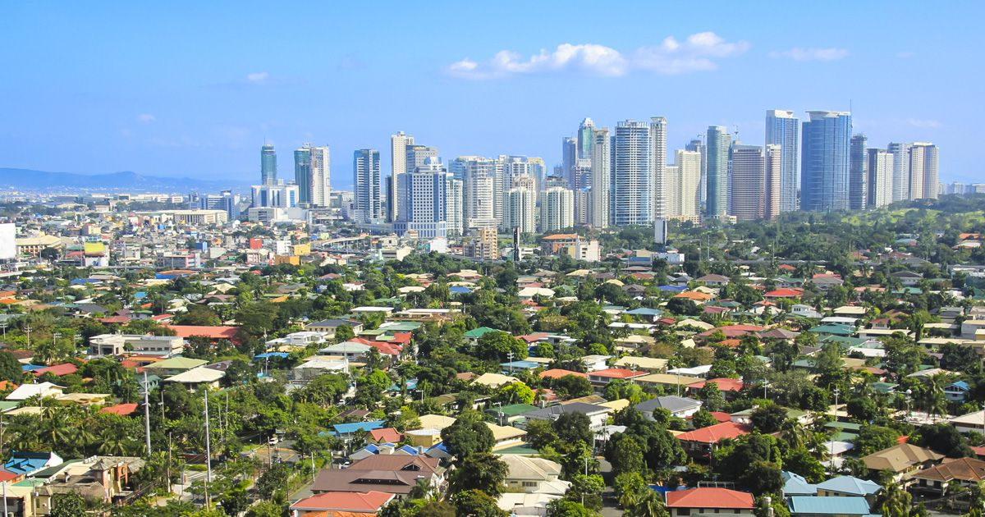

Program Type Program Terms/Deadline Areas of Study Language
Biology, Chemistry, Theology, Philosophy, Business Management, Criminal Justice, Math, Psychology, Education, History, Communication, Physics, & many more
Exchange
Fall: March 1 Spring: October 1
Courses are taught in English

Program Description
Program Type
Exchange Program
As an exchange student at Ateneo de Manila, you will have the chance to learn at one of the oldest and finest Jesuit universities in the heart of South East Asia. Thanks to our exchange agreement, Saint Peter’s students can study at Ateneo for the same cost as attending a semester in Jersey City. Room and board costs are significantly less expensive in the Philippines than in the US. Ateneo offers an incredibly rich list of courses across many disciplines – all offered in English!

Manila, Philippines
The Philippines comprises over 7,000 islands. Manila is the capital and is located on the island of Luzon. In addition to being home to the federal government, Manila is also the cultural and business center of the country. English is one of the official languages in the Philippines, and over half of the Filipino population speak it fluently. The Philippines was a colony of Spain for over 300 years, and this Spanish heritage is extremely important and evident in Manila.
Course Credits
The minimum course load for undergraduate exchange students is 12 credits per semester (4 courses). The maximum course load is 18 credits per semester.

Tuition and Financial Aid
Study abroad students pay tuition directly to Saint Peter’s University based on the regular semester charge. All governmental and Saint Peter’s institutional aid can be applied to tuition costs.

Program Fees
*Estimated cost per semester
Airline Ticket (roundtrip) $1,000-$1,500
Insurance $130
Housing (depending on accommodation) $900-$1,000
Meals $300-$400
Local Transportation $100
Personal Expenses $2,000
Books and Supplies $100

Accommodations
It is recommended that Saint Peter’s students live on campus at the Loyola Heights Quezon City campus. Students may also make your own arrangements for housing. Ateneo’s Office of International Relations can assist in finding an off-campus apartment on arrival (students will be placed in temporary on-campus housing for a week). Housing rates are between $900-$1000 per semester depending on the accommodation (apartments, rooms, number of roommates, and homestay with or without meals).
For More Info
Please visit the Center for Global Learning in room 524 of the Mac Mahon Student Center or contact Scott Keller at (201) 761-6028 or skeller1@saintpeters.edu. More information is also available on Ateneo’s website www.ateneo.edu/exchange-students.

